**No of the Experiment: 01**

**Name of the Experiment:** To configure local area Network (wired)

**Procedure:**

Step1:Start

Step2:Open Cisco Packet Tracer.

Step3:Take [end device]: PC0, Laptop0, Laptop1, Laptop2, take [Network device]:

Switch and use connection wires to connect the devices (copper straight through)

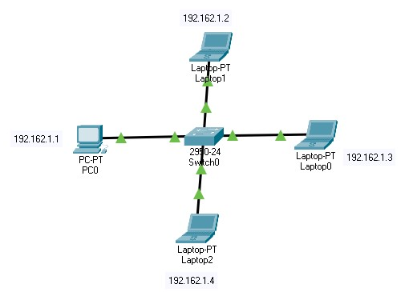

**Figure 01: Setup Layout**

Step4:IP Configuration for PC0, Laptop0, Laptop1, Laptop2

Click PC0→Desktop→IP Configuration

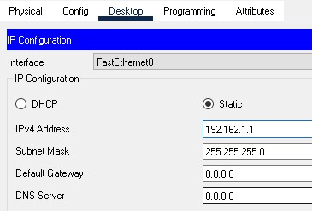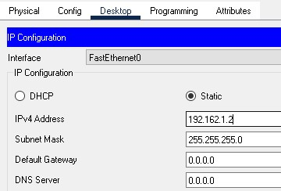

# Figure-02: PC0 IP address and gateway Figure-03: Laptop IP address and gateway setup setup

Step5:Open Command Prompt of PC0 and Sent Ping to Laptop1

**Output:**

Packet Tracer PC Command Line 1.0

C:\>ping 192.168.9.3

Pinging 192.168.9.3 with 32 bytes of data:

Reply from 192.168.9.3: bytes=32 time<1ms TTL=128

Reply from 192.168.9.3: bytes=32 time<1ms TTL=128

Reply from 192.168.9.3: bytes=32 time=1ms TTL=128

Reply from 192.168.9.3: bytes=32 time<1ms TTL=128

Ping statistics for 192.168.9.3:

Packets: Sent = 4, Received = 4, Lost = 0 (0% loss),

Approximate round trip times in milli-seconds:

Minimum = 0ms, Maximum = 1ms, Average = 0ms

**No of the Experiment: 02**

**Name of the Experiment:** To transfer packet through different network(static routing).

**Procedure:**

Step1:Start

Step2:Open Cisco Packet Tracer.

Step3:Take [end device]: PC0, PC1, Laptop0, Laptop1, take [Network device]: Switch, router and use connection wires to connect the devices (copper straight through)

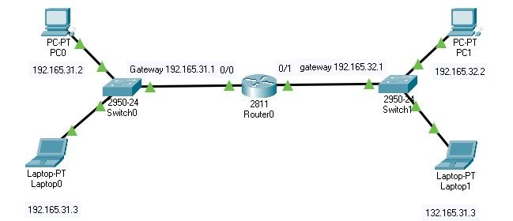

**Figure 01: Setup Layout**

Step4:IP Configuration for PC0 & PC1.

Click PC0→Desktop→IP Configuration

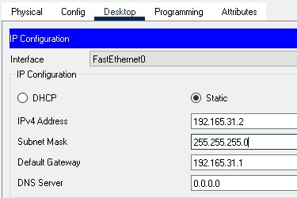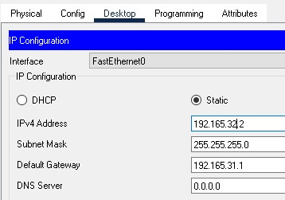

# Figure-02: PC0 IP address and gateway Figure-03: Laptop1 IP address and gateway setup setup

Step5:Router Configuration

Click Router→CLI→now write command in Configuration dialog.

Router>enable

Router#configure terminal

Router(config)#interface FastEthernet0/0

Router(config-if)#ip address 192.165.9.1 255.255.255.0

Router(config-if)#exit

Router(config)#interface FastEthernet0/1

Router(config-if)#no shutdown

Router(config-if)#ip address 192.165.10.1 255.255.255.0 Router(config-if)#exit

Step6:Open Command Prompt of PC0 and Sent Ping to PC1

**Output:**

C:\>ping 192.168.9.3

Pinging 192.168.9.3 with 32 bytes of data:

Reply from 192.168.9.3: bytes=32 time<1ms TTL=128

Reply from 192.168.9.3: bytes=32 time=1ms TTL=128

Reply from 192.168.9.3: bytes=32 time=1ms TTL=128

Reply from 192.168.9.3: bytes=32 time=1ms TTL=128

Ping statistics for 192.168.9.3:

Packets: Sent = 4, Received = 4, Lost = 0 (0% loss),

Approximate round trip times in milli-seconds:

Minimum = 0ms, Maximum = 1ms, Average = 0ms

**Experiment No: 03**

**Name of the Experiment:** Transfer packet through two different network using two router.

**Procedure:**

Step-01: First we setup a cisco packet tracer according with this figure 01.

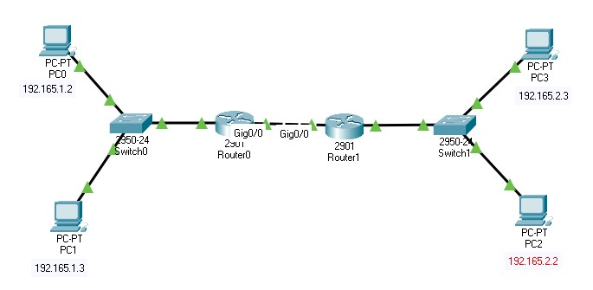

**Figure 01: Setup Layout** Step-02:Set up IP address for PC0, PC1 & PC2, PC3.

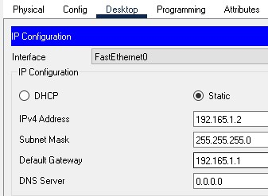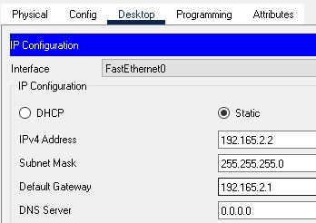

# Figure-02: PC0 IP address and gateway setup Figure-03: PC1 IP address and gateway setup Step-03: Router0 configuration

Click Router0→CLI→now write command in Configuration dialog.

Router>

Router>enable

Router#configure terminal

Router(config)#interface FastEthernet0/0

Router(config-if)#exit

Router(config)#interface FastEthernet0/0

Router(config-if)#ip address 192.165.1.1 255.255.255.0

Router(config-if)#exit

Router(config)#interface FastEthernet0/1

Router(config-if)#ip address 192.165.2.1 255.255.255.0

Router(config-if)#exit

Router(config)#exit

Router#

%SYS-5-CONFIG_I: Configured from console by console

Router#wr

Building configuration...

[OK]

Step-04: Router1 Configuration

Click Router1→CLI→now write command in Configuration dialog.

Router>en

Router#config terminal

Router(config)#interface FastEthernet0/0

Router(config-if)#ip address 192.165.4.1 255.255.255.0

Router(config-if)#exit

Router(config)#interface FastEthernet0/1

Router(config-if)#ip address 192.165.3.1 255.255.255.0

Router(config-if)#exit

Router(config)#exit

Router#

%SYS-5-CONFIG_I: Configured from console by console wr

Building configuration...

[OK]

Step-05: Route Configuration for router0

Click Router1→CLI→now write command in Configuration dialog.

Router#configure terminal

Router(config)#ip route 192.165.1.0 255.255.255.0 192.165.5.2 Router(config)#exit

Router#

%SYS-5-CONFIG_I: Configured from console by console exit

Step-06: Route Configuration for router1

Click Router1→CLI→now write command in Configuration dialog.

Router>enable

Router#configure terminal

Router(config)#ip route 192.165.2.0 255.255.255.0 192.165.5.3 Router(config)#exit

Step-07:Open Command Prompt of PC0 and Sent Ping to PC2

**Output:**

Packet Tracer PC Command Line 1.0

C:\>ping 192.165.1.2

Pinging 192.165.1.2 with 32 bytes of data:

Reply from 192.165.1.2: bytes=32 time<1ms TTL=126

Reply from 192.165.1.2: bytes=32 time<1ms TTL=126

Reply from 192.165.1.2: bytes=32 time<1ms TTL=126

Reply from 192.165.1.2: bytes=32 time<1ms TTL=126

Ping statistics for 192.165.1.2:

Packets: Sent = 4, Received = 4, Lost = 0 (0% loss),

Approximate round trip times in milli-seconds:

Minimum = 0ms, Maximum = 0ms, Average = 0ms

**Experiment No: 04**

**Name of the Experiment:** To configure dynamic IP routing through DHCP (Dynamic Host Configuration Protocol (DHCP).

**Procedure:**

Step-01: First we setup a cisco packet tracer according with this figure 01.

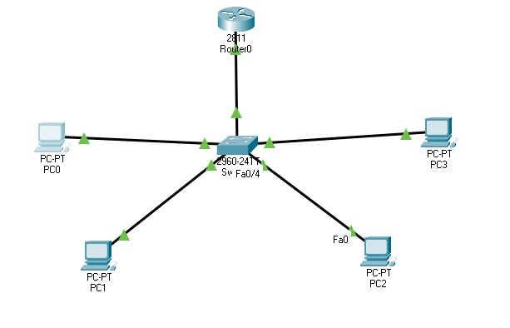

**Figure 01: Setup Configuration**

Step-02: Router0 configuration

Click Router1→CLI→now write command in Configuration dialog.

CLI Procedure:

Continue with configuration dialog? [yes/no]: no

Press RETURN to get started!

Router>enable

Router#configure terminal

Router(config)#interface fastEthernet 0/0

Router(config-if)#ip address 192.168.26.1 255.255.255.0

Router(config-if)#no shutdown

Router(config-if)#exit

Router(config)#ip dhcp pool ice

Router(dhcp-config)#network 192.168.26.0 255.255.255.0

Router(dhcp-config)#default-router 192.168.26.1

Router(dhcp-config)#exit

Router(config)#exit

Router#

Router#wr

Building configuration...

[OK]

Router#

Step-03:Open PC0 IP-Configuration and click DHCP. It automatically take IP address from DHCP server.

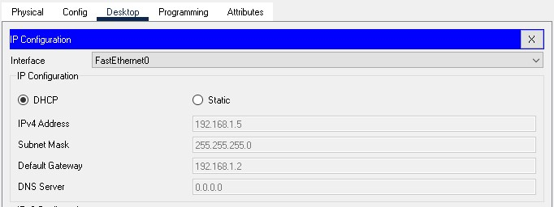

The other PC’s also take IP address dynamically from DHCP server.

Step-04: Open Command Prompt of PC0 and Sent Ping to PC1

Packet Tracer PC Command Line 1.0

C:\>ping 192.168.1.5

Pinging 192.168.1.5 with 32 bytes of data:

Reply from 192.168.1.5: bytes=32 time<1ms TTL=128

Reply from 192.168.1.5: bytes=32 time<1ms TTL=128

Reply from 192.168.1.5: bytes=32 time<1ms TTL=128

Reply from 192.168.1.5: bytes=32 time<1ms TTL=128

Ping statistics for 192.168.31.2:

Packets: Sent = 4, Received = 4, Lost = 0 (0% loss),

Approximate round trip times in milli-seconds:

Minimum = 0ms, Maximum = 0ms, Average = 0ms

C:\>